

COMPANY RATING WEBSITE

SOFTWARE REQUIREMENT SPECIFICATION

*Report #1*

|  |  |  |
| --- | --- | --- |
| **COMPANY RATING WEBSITE – *KẾ SINH NHAI TEAM*** | | |
| **Group Members** | Trần Quốc Hưng | SE02970 |
| Nguyễn Sơn Lâm | SE03090 |
| Nguyễn Việt Hùng | SE03293 |
| Nguyễn Nhật Quang | SE03122 |
| Trần Đăng | SE03039 |
| **Supervisor** | Bùi Đình Chiến | |
| **Project code** | CRW | |

**- Hanoi, 28/05/2016 -**

# SIGNATURE PAGE

**AUTHORS**: Trần Đăng 28/05/2016

*Team member*

Nguyễn Nhật Quang 28/05/2016

*Team member*

**REVIEWER**: Trần Quốc Hưng 29/05/2016

*Project Leader*

**APPROVAL**: Bùi Đình Chiến 03/06/2016

*Supervisor*

# Record of change

*A – Added; M – Modified; D – Deleted

|  |  |  |  |  |  |
| --- | --- | --- | --- | --- | --- |
| Effective Date | Changed Item | A,M,D* | Change Description | Reason for Change | Rev. Number |
| 28/05/2016 | Software Requirements Specification | A | First version | Create Software Requirements Specifications | 1.0 |
|  |  |  |  |  |  |
|  |  |  |  |  |  |

# Table of Contents

SIGNATURE PAGE 2

Record of change 3

Table of Contents 4

1. INTRODUCTION 7

1.1. Purpose 7

1.2. Definitions and Acronyms 7

1.3. System Purpose 7

2. OVERALL DESCRIPTION 8

2.1. System Overview 8

2.2. Use Case Diagram 9

2.3. Product Features 10

2.4. User Characteristics 11

2.5. User Documentation 11

2.6. Assumption 11

2.7. Entity-Relationship Model 12

2.7.1. Entity-Relationship Diagram 12

2.7.2. Entity Detail 12

E01. RegisteredUser 12

E02. Email-PasswordInformation 12

E03. 3rdPartyInformation 13

E04. Company 13

E05. OverallReview 13

E06. SalaryAndBenefitReview 14

E07. Job 14

E08. Comment 15

E09. Notification 15

E10. Report 15

E11. BookmarkList 15

E12. FollowList 15

3. FUNCTIONAL SPECIFICATION 16

3.1. Business rule 16

3.2. Use Case 17

3.2.1. User 17

**UC001 - View Reviews** 18

**UC002 – Search Review** 19

**UC003 - View Companies** 21

**UC004 – Search Company** 22

**UC005 – View Comments** 24

3.2.2. Guest 25

**UC006 – Register** 26

**UC007 – Create Review (Anonymous)** 28

3.2.3. Member/Administrator 29

**UC008 – Login** 30

**UC009 – Logout** 31

**UC010 – View Notifications** 32

**UC011 – Receive Notification** 33

**UC012 – View Account Info** 35

**UC013 – Update Account Info** 36

**UC014 – Change Password** 37

**UC015 – Forgot Password** 38

**UC016 – Add Comment** 40

**UC017 – Remove Comment** 41

**UC018 – Add Company** 43

3.2.4. Member 44

**UC019 – Manage Followed Companies** 45

**UC020 – Follow Company** 46

**UC021 – Unfollow Company** 47

**UC022 – Manage Reviews** 49

**UC023 – Create Review** 50

**UC024 – Update Review** 51

**UC025 – Remove Review** 52

**UC026 – Report Review** 53

**UC027 – Upvote Review** 54

**UC028 – Remove Review Upvote** 55

**UC029 – Manage Bookmarks** 57

**UC030 – Add Bookmark** 58

**UC031 – Remove Bookmark** 59

3.2.5. Administrator 60

**UC032 – Manage Companies** 61

**UC033 – Update Company** 62

**UC034 – Remove Company** 63

**UC035 – Manage Reports** 65

**UC036 – Approve Report** 66

**UC037 – Manage Accounts** 68

**UC038 – Search Account** 69

**UC039 – Change Account State** 70

4. NON-FUNCTIONAL SPECIFICATION 71

4.1. Reliability 71

4.2. Performance Requirements 71

4.2.1. Availability 71

4.2.2. Response time 71

4.2.3. Maintainability 71

4.3. Hardware/Software Requirements 71

4.4. Information Requirements 71

# INTRODUCTION

## Purpose

This document is created as the introduction for project Company Rating Website – our Capstone Project at FPT University. In this document, we provide the description of functional requirements and non-functional requirements. These requirements will assure that the system will correctly and reliably perform its intended functions. The specification will provide general as well as specific requirements to be used in the design, testing and validation of the system. It is intended for both stakeholders and the project team of the system.

## Definitions and Acronyms

1. Definitions and Acronyms

|  |  |  |
| --- | --- | --- |
| Acronyms | Definition | Note |
| CRW | Company Rating Website | Project’s name |
| SRS | Software Requirements Specification |  |
| U | User | Including Guest, Member, Moderator and Administrator |
| M | Member |  |
| RU | Registered User | Including Member, Moderator and Administrator |
| AD | Administration | Including Moderator and Administrator |
| URL | Uniform Resource Locator | Website’s hyperlink |

## System Purpose

Nowadays people have multiple ways to hand in their CVs, be it directly or virtually. The problem lies on whether they would fit with the company of choice. To that end, we have decided to create a website that may bring a solution to the proposed problem.

CRW helps it user to have an insider’s view from employees/ex-employees’ review on any available company. Everyone who comes to this website would be able to read and create reviews as they like, be it about the profession’s upbringing, the opinions of those who worked there, or just simply how well the employee would be treated.

# OVERALL DESCRIPTION

## System Overview



1. System Overview Diagram

## Use Case Diagram

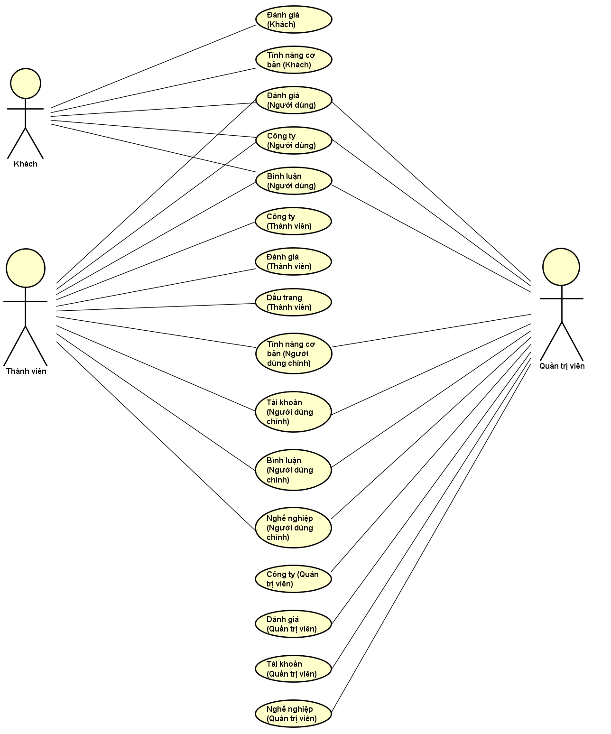

1. Use Case Digram

## Product Features

1. List system’s function via Use Case, grouped by actor(s) of said function. Common functions are grouped seperately.

|  |  |  |  |
| --- | --- | --- | --- |
| Use Case No. | Function Group | Function | Note |
| User | | | |
| UC001 | Review | View Reviews |  |
| UC002 | Search Review |  |
| UC003 | Company | View Companies |  |
| UC004 | Search Company |  |
| UC005 | Comment | View Comments |  |
| Guest | | | |
| UC006 | Common | Register |  |
| UC007 | Review | Create Review (Anonymous) |  |
| Member/Administrator | | | |
| UC008 | Common | Login |  |
| UC009 | Logout |  |
| UC010 | View Notifications |  |
| UC011 | Receive Notification |  |
| UC012 | Account | View Account Info |  |
| UC013 | Update Account Info |  |
| UC014 | Change Password |  |
| UC015 | Forgot Password |  |
| UC016 | Comment | Add Comment |  |
| UC017 | Remove Comment |  |
| UC018 | Add Company |  |
| Member | | | |
| UC019 | Company | Manage Followed Companies |  |
| UC020 | Follow Company |  |
| UC021 | Unfollow Company |  |
| UC022 | Review | Manage Reviews |  |
| UC023 | Create Review |  |
| UC024 | Update Review |  |
| UC025 | Remove Review |  |
| UC026 | Report Review |  |
| UC027 | Upvote Review |  |
| UC028 | Remove Review Upvote |  |
| UC029 | Bookmark | Manage Bookmarks |  |
| UC030 | Add Bookmark |  |
| UC031 | Remove Bookmark |  |
| Administrator | | | |
| UC032 | Company | Manage Companies |  |
| UC033 | Update Company |  |
| UC034 | Remove Company |  |
| UC035 | Review | Manage Reports |  |
| UC036 | Approve Report |  |
| UC037 | Account | Manage Accounts |  |
| UC038 | Search Account |  |
| UC039 | Change Account State |  |

## User Characteristics

CRW allows users to search, view or create any amount of reviews for a company they have previously worked at. All reviews will be proof-readed by Administrators and Moderators to maintain its integrity before being posted on CRW. Other users may follow and comment on the review, even report if needed. As such, users are given the chance to have a more generalized view on a company.

CRW has 3 objective users:

* Guest: Non-registered user, can use basic function such as Search Review, View Review, etc...
* Member: Has registered an account, can use most functions available, such as Login, Logout, Manage Reviews, Report, Follow Company, etc…
* Admin: Has access to all functions avilable with an Administration control panel for Manage Account, Manage Reports, Manage Company, etc.

## User Documentation

User Guide: Provide detailed explanation about the system, screens and guide users how to use all features of CRW.

## Assumption

* Receive the guidance and great support of the overseeing teacher.
* None of the members got severely ill during the software development process.
* No device failure during the software development process.
* All reports and tasks meet their deadline.
* No internal conflict during the whole project.

## Entity-Relationship Model

### Entity-Relationship Diagram

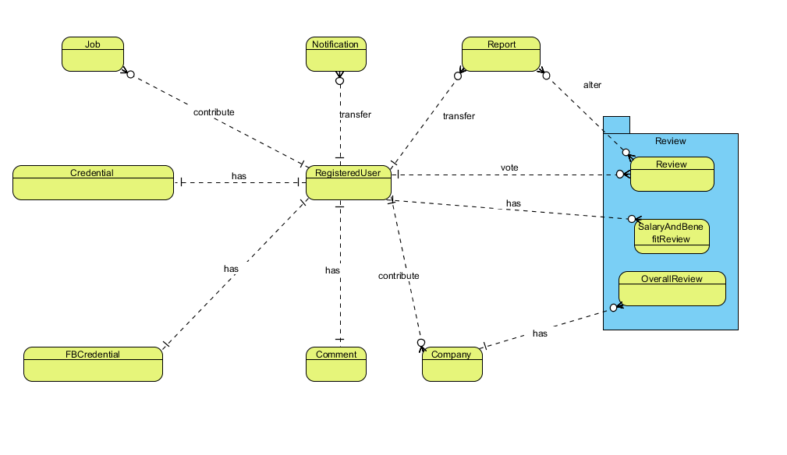

1. Entity-Relationship Diagram

### Entity Detail

#### RegisteredUser

1. List of RegisteredUser properties

|  |  |  |  |  |
| --- | --- | --- | --- | --- |
| No | Name | Type | Required | Description |
|  | name | String | Y | Displayed name |
|  | profileImageURL | String | N | Account’s avatar |
|  | signInType | String | Y | User’s sign in method |
|  | description | String | N | Account’s personal info |
|  | roles | String | Y | Account type (Member, Administrator) |
|  | accState | String | Y | Account state (Active, Banned) |

#### Email-PasswordInformation

1. List of Email-PasswordInformation properties

|  |  |  |  |  |
| --- | --- | --- | --- | --- |
| No | Name | Type | Required | Description |
|  | email | String | Y | Account’s email |
|  | password | String | N | Password if account is registered with an email |
|  | salt | String | N | Support password encryptions |
|  | resetPasswordToken | String | N | Token used in password reset |
|  | resetPasswordExpires | Date | N | Token’s expire date |

#### 3rdPartyInformation

1. List of 3rdPartyInformation properties

|  |  |  |  |  |
| --- | --- | --- | --- | --- |
| Số | Thuộc tính | Kiểu dữ liệu | Bắt buộc | Mô tả |
|  | id | String | Y | 3rd party ID |
|  | accessToken | String | Y | 3rd party access token |
|  | email | String | Y | User’s email used by 3rd party |
|  | name | String | Y | Displayed name in 3rd party application |
|  | first_name | String | Y | First name in 3rd party application |
|  | last_name | String | Y | Last name in 3rd party application |
|  | picture | GridFS | Y | 3rd party account’s avatar |

#### Company

1. List of Company properties

|  |  |  |  |  |
| --- | --- | --- | --- | --- |
| No | Name | Type | Required | Description |
|  | _id | ObjectID | Y | An identifier for companies |
|  | name | String | Y | Company’s name |
|  | alias | Array | N | Company’s aliases |
|  | avatar | String | Y | Company’s avatar |
|  | description | String | Y | Company’s detailed info |
|  | website | String | Y | Company’s website |
|  | personnelSize | String | N | Company’s personnel size |
|  | companyType | String | N | Company’s type |
|  | hq | String | N | Company’s headquarter |
|  | founded | Date | N | Company’s founded date |
|  | industry | String | N | Company’s industrial focus |
|  | contact | String | N | Company’s contact |
|  | photo | Array | N | Company’s photoes |
|  | video | Array | N | Company’s video |
|  | state | String | Y | Company’s current state (Active, Locked) |
|  | overallRating | Number | N | Company’s overall rating |
|  | averageRating | Number | N | Company’s average rating |

#### OverallReview

1. List of Overall Review properties

| No | Name | Type | Required | Description |
| --- | --- | --- | --- | --- |
|  | _id | ObjectID | Y | An identifier for reviews |
|  | userID | ObjectID | Y | An identifier for reviewers |
|  | stayAnonymous | Boolean | N | Anonimity of the reviewer |
|  | highlight | Boolean | N | State of reviews’ highlight |
|  | title | String | Y | Review’s title |
|  | job | Array | Y | Reviewer’s profession |
|  | isJobCurrent | String | N | Reviewer’s current state of profession |
|  | jobLength | String | N | Reviewer’s time soent as stated profession |
|  | contract | String | N | Reviewer’s type of contract |
|  | pros | String | N | Review’s pros regarding the company |
|  | cons | String | N | Review’s cons regarding the company |
|  | supplement | String | N | Additional information regarding the company |
|  | rating | Number | Y | Review’s grading of the company |
|  | upvoteCount | Number | Y | Review’s amount of upvote |
|  | upvoteUser | Array | Y | Review’s upvoter pool |
|  | state | String | Y | Review’s state (Approved, Rejected, Pending) |
|  | lastUpdated | Date | N | Review’s last updated date |

#### SalaryAndBenefitReview

1. List of SalaryAndBenefitReview properties

|  |  |  |  |  |
| --- | --- | --- | --- | --- |
| No | Name | Type | Required | Description |
|  | _id | ObjectID | Y | An identifier for reviews |
|  | userID | ObjectID | Y | An identifier for reviewers |
|  | stayAnonymous | Boolean | N | Anonimity of the reviewer |
|  | highlight | Boolean | N | State of reviews’ highlight |
|  | title | String | Y | Review’s title |
|  | job | Array | Y | Reviewer’s profession |
|  | isJobCurrent | String | N | Reviewer’s current state of profession |
|  | jobLength | String | N | Reviewer’s time soent as stated profession |
|  | contract | String | N | Reviewer’s type of contract |
|  | basePay | Number | Y | Reviewer’s base payment |
|  | payRaise | Number | N | Reviewer’s adjusted payment raise |
|  | cashBonus | Number | N | Reviewer’s bonus in cash |
|  | profitSharing | Number | N | Reviewer’s share in profit |
|  | healthRating | Number | N | Reviewer’s grading on healthcare policies |
|  | opportunity Rating | Number | N | Reviewer’s grading on promotion opportunity |
|  | parentalLeaveRating | Number | N | Reviewer’s grading on parental leave policies |
|  | timeOffRating | Number | N | Reviewer’s grading on paid leave policies |
|  | pensionRating | Number | N | Reviewer’s grading on pension policies |
|  | supplement | String | N | Additional information regarding the company |
|  | upvoteCount | Number | Y | Review’s amount of upvote |
|  | upvoteUser | Array | Y | Review’s upvoter pool |
|  | state | String | Y | Review’s state (Approved, Rejected, Pending) |
|  | lastUpdated | Date | N | Review’s last updated date |

#### Job

1. List of Job properties

|  |  |  |  |  |
| --- | --- | --- | --- | --- |
| No | Name | Type | Required | Description |
| 1. 1 | _id | ObjectID | Y | An identifier for professions |
|  | name | String | Y | Profession’s name |

#### Comment

1. List of Comment properties

|  |  |  |  |  |
| --- | --- | --- | --- | --- |
| No | Name | Type | Required | Description |
|  | _id | ObjectID | Y | An identifier for comments |
|  | userID | ObjectID | Y | Comment’s writer |
|  | content | String | Y | Comment’s content |

#### Notification

1. List of Notification properties

|  |  |  |  |  |
| --- | --- | --- | --- | --- |
| No | Name | Type | Required | Description |
|  | _id | ObjectID | Y | An identifier for notifications |
|  | message | String | Y | Notification’s content |
|  | targetLink | String | Y | Notification’s hyperlink |
|  | hasRead | Boolean | Y | Notification’s state (Read, Not Read) |

#### Report

1. List of Report properties

|  |  |  |  |  |
| --- | --- | --- | --- | --- |
| No | Name | Type | Required | Description |
|  | _id | ObjectID | Y | An identifier for reports |
|  | user | ObjectID | Y | An identifier for reporters |
|  | content | String | Y | Report’s content |
|  | isConsidered | String | Y | Report’s state |

#### BookmarkList

1. List of BookmarkList properties

|  |  |  |  |  |
| --- | --- | --- | --- | --- |
| No | Name | Type | Required | Description |
|  | _id | ObjectID | Y | An identifier for bookmark |
|  | userID | ObjectID | Y | An identifier for user |
|  | reviewID | ObjectID | Y | An identifier for review |

#### FollowList

1. List of FollowList properties

|  |  |  |  |  |
| --- | --- | --- | --- | --- |
| No | Name | Type | Required | Description |
|  | _id | ObjectID | Y | An identifier for bookmark |
|  | userID | ObjectID | Y | An identifier for user |
|  | companyID | ObjectID | Y | An identifier for company |

# FUNCTIONAL SPECIFICATION

## Business rule

1. List of required business rules

|  |  |
| --- | --- |
| No | Definition |
|  | Search textbox must have more than 2 letters input |
|  | Name must not be blank |
|  | Name must not be more than 100 characters |
|  | When User access to a non-existing page, CRW display message “Trang không tồn tại” |
|  | Email format must be followed |
|  | Guest cannot view Registered User info |
|  | Displayed date format must be DD/MM/YYYY |
|  | Date input format is datetime |
|  | Number is rounded up to 2 decimal numbers |
|  | Money unit must be VND |
|  | Guest can create a review without logging in |
|  | Password must have more than 8 characters, 1 uppercase, 1 special, 1 number |
|  | File size limit is 1 mb |

## Use Case

### User

Reviews

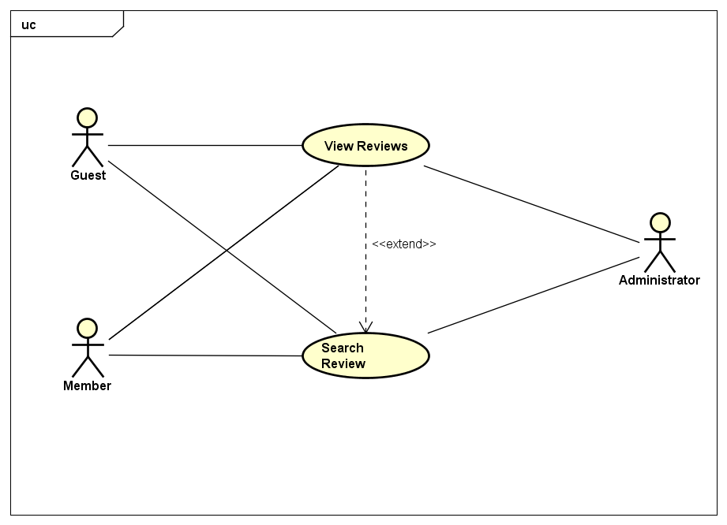

1. Review Group Use Cases for User

#### UC001 - View Reviews

1. Detailed Use Case description and User - System interactions

|  |  |  |  |  |
| --- | --- | --- | --- | --- |
| Use Case ID | | UC001 | Version | 1.0 |
| Use Case Name | | View Reviews | | |
| Author | | Trần Đăng | **Last Updated** | 26/05/2016 |
| Primary Actor | | User | **Secondary Actor** |  |
| Description | | Display review in details | | |
| Preconditions | | Review exists  Currently at Detailed Company screen | | |
| Postconditions | | Detailed Review screen is displayed | | |
| Normal Flow | | | | |
| Step | **Actor** | **Action** | | |
| 1 | User | Click on Review’s title | | |
| 2 | System | Display Detailed Review screen with the chosen review’s info | | |
|  | | | | |
| Alternative Flows | | | | |
| AT1 | User access the Review through an existing URL | | | |
| Step | **Actor** | **Action** | | |
| 1 | User | Open the URL for the Review | | |
| 2 | System | Display Detailed Review screen with the chosen review’s info | | |
|  | | | | |
| Exceptions: None | | | | |
| Priority | | High | | |
| Frequency of Use | | High | | |
| Business Rules | | B4 | | |

#### UC002 – Search Review

1. Detailed Use Case description and User - System interactions

|  |  |  |  |  |
| --- | --- | --- | --- | --- |
| Use Case ID | | UC002 | Version | 1.0 |
| Use Case Name | | Search Review | | |
| Author | | Trần Đăng | **Last Updated** | 26/05/2016 |
| Primary Actor | | User | **Secondary Actor** |  |
| Description | | Search for review of a company, possibily with filter | | |
| Preconditions | | Currently at Detailed Company screen | | |
| Postconditions | | Matching reviews are displayed | | |
| Normal Flow | | | | |
| Step | **Actor** | **Action** | | |
| 1 | User | Input search query | | |
| 2 | System | Display Detailed Company screen with matching result | | |
|  | | | | |
| Alternative Flows | | | | |
| AT1 | After step 2, User wants to sort the search result | | | |
| Step | **Actor** | **Action** | | |
| 3 | User | Click on “Đánh giá”, “Thời gian” or “Ủng hộ” | | |
| 4 | System | Sort the search result accordingly | | |
|  | | | | |
| AT2 | After step 2, User wants to limit the amount of search result on a single page | | | |
| Step | **Actor** | **Action** | | |
| 3 | User | Click on the dropdown list next to “Hiển thị” and choose 5, 10 or 20 | | |
| 4 | System | Limit the search result accordingly | | |
|  | | | | |
| Exceptions: None | | | | |
| EX1 | At step 2, if there’s no possible result | | | |
| Step | **Actor** | **Action** | | |
| 2 | System | Display message “0 kết quả cho từ khóa [search query]” | | |
| Priority | | High | | |
| Frequency of Use | | High | | |
| Business Rules | | B1 | | |

Company

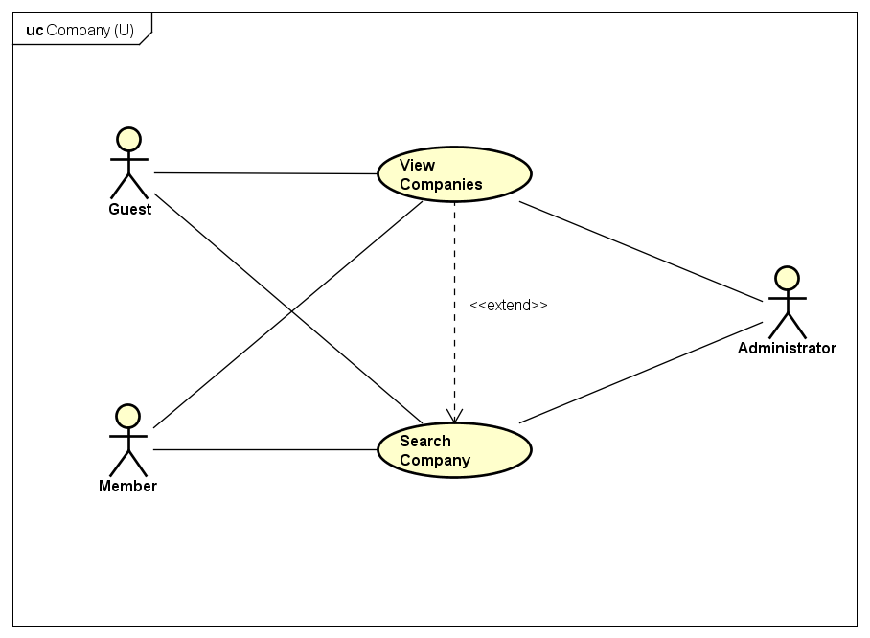

1. Company Group Use Cases for User

#### UC003 - View Companies

1. Detailed Use Case description and User - System interactions

|  |  |  |  |  |
| --- | --- | --- | --- | --- |
| Use Case ID | | UC003 | Version | 1.0 |
| Use Case Name | | View Companies | | |
| Author | | Trần Đăng | **Last Updated** | 26/05/2016 |
| Primary Actor | | User | **Secondary Actor** |  |
| Description | | Displays a company’s information | | |
| Preconditions | | Company exists | | |
| Postconditions | | Detailed Company screen is displayed | | |
| Normal Flow | | | | |
| Step | **Actor** | **Action** | | |
| 1 | User | Click on Company’s name | | |
| 2 | System | Display Detailed Company screen with the chosen company’s info | | |
|  | | | | |
| Alternative Flows | | | | |
| AT1 | User access the Company through an existing URL | | | |
| Step | **Actor** | **Action** | | |
| 1 | User | Open the URL for the Company | | |
| 2 | System | Display Detailed Company screen with the chosen company’s info | | |
|  | | | | |
| Exceptions: None | | | | |
| Priority | | High | | |
| Frequency of Use | | High | | |
| Business Rules | | B4 | | |

#### UC004 – Search Company

1. Detailed Use Case description and User - System interactions

|  |  |  |  |  |
| --- | --- | --- | --- | --- |
| Use Case ID | | UC004 | Version | 1.0 |
| Use Case Name | | Search Company | | |
| Author | | Trần Đăng | **Last Updated** | 26/05/2016 |
| Primary Actor | | User | **Secondary Actor** |  |
| Description | | Search for a company, possibily with filter | | |
| Preconditions | | Searchbar is clicked upon | | |
| Postconditions | | Matching companies are displayed | | |
| Normal Flow | | | | |
| Step | **Actor** | **Action** | | |
| 1 | User | Input search query | | |
| 2 | System | Display Search Result screen with matching result | | |
|  | | | | |
| Alternative Flows | | | | |
| AT1 | After step 2, User wants to sort the search result | | | |
| Step | **Actor** | **Action** | | |
| 3 | User | Click on “Đánh giá” or “Tên công ty” | | |
| 4 | System | Sort the search result accordingly | | |
|  | | | | |
| AT2 | After step 2, User wants to limit the amount of search result on a single page | | | |
| Step | **Actor** | **Action** | | |
| 3 | User | Click on the dropdown list next to “Hiển thị” and choose 8, 16 or 32 | | |
| 4 | System | Limit the search result accordingly | | |
|  | | | | |
| Exceptions | | | | |
| EX1 | At step 2, if there’s no possible result | | | |
| Step | **Actor** | **Action** | | |
| 4 | System | Display message “0 kết quả cho từ khóa [search query]” | | |
| Priority | | High | | |
| Frequency of Use | | High | | |
| Business Rules | | B1 | | |

Comment

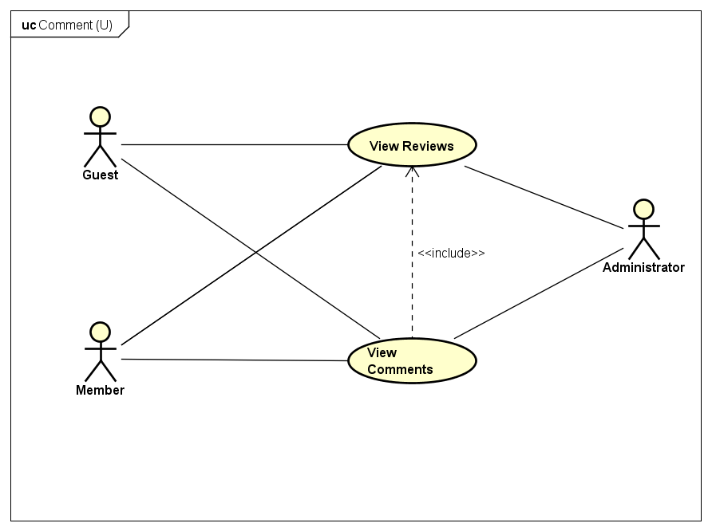

1. Comment Group Use Cases for User

#### UC005 – View Comments

1. Detailed Use Case description and User - System interactions

|  |  |  |  |  |
| --- | --- | --- | --- | --- |
| Use Case ID | | UC005 | Version | 1.0 |
| Use Case Name | | View Comments | | |
| Author | | Trần Đăng | **Last Updated** | 26/05/2016 |
| Primary Actor | | User | **Secondary Actor** |  |
| Description | | Display comments from a review | | |
| Preconditions | | Review exists  Currently at Detailed Company screen | | |
| Postconditions | | Comments are displayed | | |
| Normal Flow | | | | |
| Step | **Actor** | **Action** | | |
| 1 | User | Click on Review’s title | | |
| 2 | System | Display Detailed Review screen with the chosen review’s comments | | |
|  | | | | |
| Alternative Flows | | | | |
| AT1 | User access the Review through an existing URL | | | |
| Step | **Actor** | **Action** | | |
| 1 | User | Open the URL for the Review | | |
| 2 | System | Display Detailed Review screen with the chosen review’s comments | | |
|  | | | | |
| Exceptions: None | | | | |
| Priority | | Low | | |
| Frequency of Use | | High | | |
| Business Rules | | B4 | | |

### Guest

Common

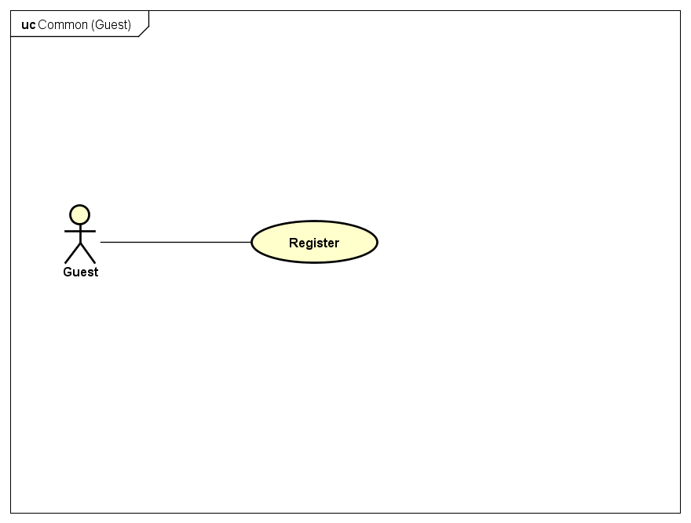

1. Common Group Use Cases for Guest

#### UC006 – Register

1. Detailed Use Case description and Guest - System interactions

|  |  |  |  |  |  |
| --- | --- | --- | --- | --- | --- |
| Use Case ID | | UC006 | Version | 1.0 | |
| Use Case Name | | Register | | | |
| Author | | Trần Đăng | **Last Updated** | 26/05/2016 | |
| Primary Actor | | Guest | **Secondary Actor** |  | |
| Description | | Register to become a Member of CRW | | | |
| Preconditions | | None | | | |
| Postconditions | | Account is successfully created | | | |
| Normal Flow | | | | | |
| Step | **Actor** | **Action** | | | |
| 1 | Guest | Click on “Đăng nhập” on the navbar | | | |
| 2 | System | Show Login screen | | | |
| 3 | Guest | Click on “Đăng ký ngay” on the screen | | | |
| 4 | System | Show Register screen | | | |
| 5 | Guest | Input info as required and click “Đăng ký” | | | |
| 6 | System | Create and save a new account with inputted info in the System | | | |
|  | | | | |
| Alternative Flows | | | | | |
| AT1 | At step 3 Guest choose to register with a Facebook account | | | | |
| Step | **Actor** | **Action** | | | |
| 3 | Guest | Click on “Đăng nhập với tài khoản Facebook” | | | |
| 4 | System | Opens a new popup window redirecting to Facebook authentication | | | |
| 5 | Guest | Accept request for account linking | | | |
| 6 | System | Save account info in the System | | | |
|  | | | | | |
| Exceptions | | | | | |
| EX1 | At step 5 Guest did not input all required info | | | | |
| Step | **Actor** | **Action** | | | |
| 6 | System | Display error messages accordingly and halt guest progress until cleared | | | |
| Priority | | High | | | |
| Frequency of Use | | Normal | | | |
| Business Rules | | B2, B3, B5, B11, B12 | | | |

Reviews

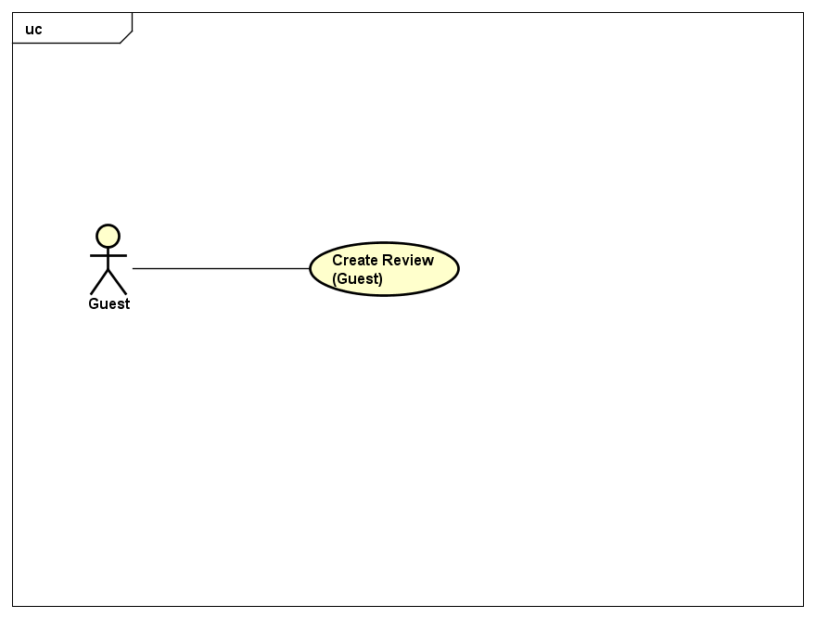

1. Review Group Use Cases for Guest

#### UC007 – Create Review (Anonymous)

1. Detailed Use Case description and Guest - System interactions

|  |  |  |  |  |
| --- | --- | --- | --- | --- |
| Use Case ID | | UC007 | Version | 1.0 |
| Use Case Name | | Create Review (Anonymous) | | |
| Author | | Trần Đăng | **Last Updated** | 26/05/2016 |
| Primary Actor | | Guest | **Secondary Actor** |  |
| Description | | Post a review to CRW without an account | | |
| Preconditions | | Currently at Detailed Company screen | | |
| Postconditions | | Review is saved in the system | | |
| Normal Flow | | | | |
| Step | **Actor** | **Action** | | |
| 1 | Guest | Click on “+ Đánh giá” | | |
| 2 | System | Display Create Review page | | |
| 3 | Guest | Input info as required and click “Gửi đánh giá” | | |
| 4 | System | Save the review into the system with pending state | | |
|  | | | | |
| Alternative Flows: None | | | | |
|  | | | | |
| Exceptions | | | | |
| EX1 | At step 3 Guest did not input all required info | | | |
| Step | **Actor** | **Action** | | |
| 4 | System | Display error messages accordingly and halt guest progress until cleared | | |
|  | | | | |
| Priority | | Normal | | |
| Frequency of Use | | High | | |
| Business Rules | | B11 | | |

### Member/Administrator

Common

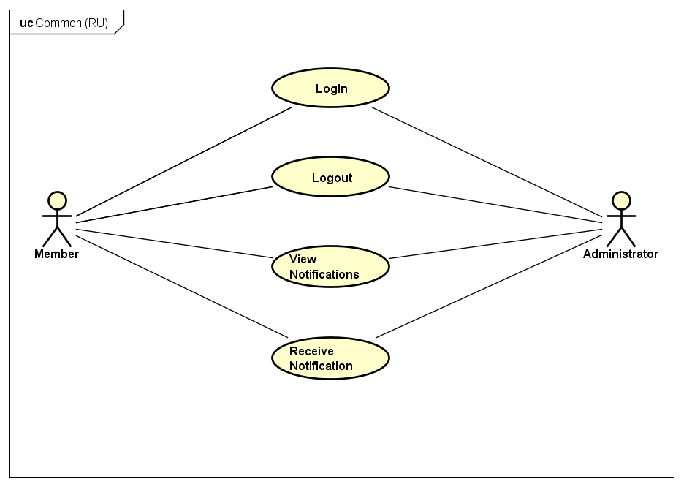

1. Common Group Use Cases for Registered User

#### UC008 – Login

1. Detailed Use Case description and Registered User - System interactions

|  |  |  |  |  |
| --- | --- | --- | --- | --- |
| Use Case ID | | UC008 | Version | 1.0 |
| Use Case Name | | Login | | |
| Author | | Trần Đăng | **Last Updated** | 26/05/2016 |
| Primary Actor | | RU | **Secondary Actor** |  |
| Description | | Login to an account on CRW | | |
| Preconditions | | Currently not logged in | | |
| Postconditions | | Login successfully | | |
| Normal Flow | | | | |
| Step | **Actor** | **Action** | | |
| 1 | RU | Click on “Đăng nhập” on navbar | | |
| 2 | System | Show Login screen | | |
| 3 | RU | Input account credentials as required and click “Đăng nhập” | | |
| 4 | System | Log the RU in with the account of choice | | |
|  | | | | |
| Alternative Flows | | | | |
| AT1 | At step 3 RU Login by Facebook account | | | |
| Step | **Actor** | **Action** | | |
| 3 | RU | Click on “Đăng nhập với tài khoản Facebook” | | |
| 4 | System | Log the RU in with the account of choice | | |
|  | | | | |
| Exceptions | | | | |
| EX1 | At step 3 RU did not input all required info | | | |
| Step | **Actor** | **Action** | | |
| 4 | System | Display error messages accordingly and halt RU progress until cleared | | |
|  | | | | |
| EX2 | At step 3 RU’s account is banned | | | |
| Step | **Actor** | **Action** | | |
| 4 | System | Display error messages accordingly and halt RU progress until cleared | | |
|  | | | | |
| EX3 | At step 3 of AT1 RU’s account is banned | | | |
| Step | **Actor** | **Action** | | |
| 4 | System | Display error messages accordingly and halt RU progress until cleared | | |
| Priority | | High | | |
| Frequency of Use | | High | | |
| Business Rules | | None | | |

#### UC009 – Logout

1. Detailed Use Case description and Registered User - System interactions

|  |  |  |  |  |
| --- | --- | --- | --- | --- |
| Use Case ID | | UC009 | Version | 1.0 |
| Use Case Name | | Logout | | |
| Author | | Trần Đăng | **Last Updated** | 26/05/2016 |
| Primary Actor | | RU | **Secondary Actor** |  |
| Description | | Logout from current account on CRW | | |
| Preconditions | | Logged in | | |
| Postconditions | | Logout successfully | | |
| Normal Flow | | | | |
| Step | **Actor** | **Action** | | |
| 1 | RU | Click on “Đăng xuất” on navbar’s dropdown menu | | |
| 2 | System | Log the RU out of the account | | |
|  | | | | |
| Alternative Flows: None | | | | |
|  | | | | |
| Exceptions: None | | | | |
| Priority | | High | | |
| Frequency of Use | | High | | |
| Business Rules | | None | | |

#### UC010 – View Notifications

1. Detailed Use Case description and Registered User - System interactions

|  |  |  |  |  |
| --- | --- | --- | --- | --- |
| Use Case ID | | UC010 | Version | 1.0 |
| Use Case Name | | View Notifications | | |
| Author | | Trần Đăng | **Last Updated** | 26/05/2016 |
| Primary Actor | | RU | **Secondary Actor** |  |
| Description | | View all notifications sent by system | | |
| Preconditions | | Logged in | | |
| Postconditions | | Notification screen is displayed | | |
| Normal Flow | | | | |
| Step | **Actor** | **Action** | | |
| 1 | RU | Click on “Thông báo” on navbar | | |
| 2 | System | Show Notification screen | | |
|  | | | | |
| Alternative Flows | | | | |
| AT1 | After step 2 RU wants to see the notification’s trigger | | | |
| Step | **Actor** | **Action** | | |
| 3 | RU | Click on “Tới đường dẫn đính kèm” | | |
| 4 | System | Display the screen accordingly | | |
|  | | | | |
| Exceptions | | | | |
| EX1 | After step 1 RU has yet to receive any notification | | | |
| Step | **Actor** | **Action** | | |
| 2 | System | Show message “Bạn chưa có thông báo nào” | | |
| Priority | | Normal | | |
| Frequency of Use | | High | | |
| Business Rules | | None | | |

#### UC011 – Receive Notification

1. Detailed Use Case description and Registered User - System interactions

|  |  |  |  |  |
| --- | --- | --- | --- | --- |
| Use Case ID | | UC011 | Version | 1.0 |
| Use Case Name | | Receive Notification | | |
| Author | | Trần Đăng | **Last Updated** | 26/05/2016 |
| Primary Actor | | RU | **Secondary Actor** |  |
| Description | | Receive a notification from System | | |
| Preconditions | | Logged in | | |
| Trigger | | Followed company has a new review  RU’s review has a new comment  RU’s review is warned by AD | | |
| Postconditions | | Receive Notification successfully | | |
| Normal Flow | | | | |
| Step | **Actor** | **Action** | | |
| 1 | RU | Register to the Receive Notification pool | | |
| 2 | System | Send Notification to RU in the Receive Notification pool when triggered | | |
|  | | | | |
| Alternative Flows: None | | | | |
|  | | | | |
| Exceptions: None | | | | |
| Priority | | Normal | | |
| Frequency of Use | | High | | |
| Business Rules | | None | | |

Account

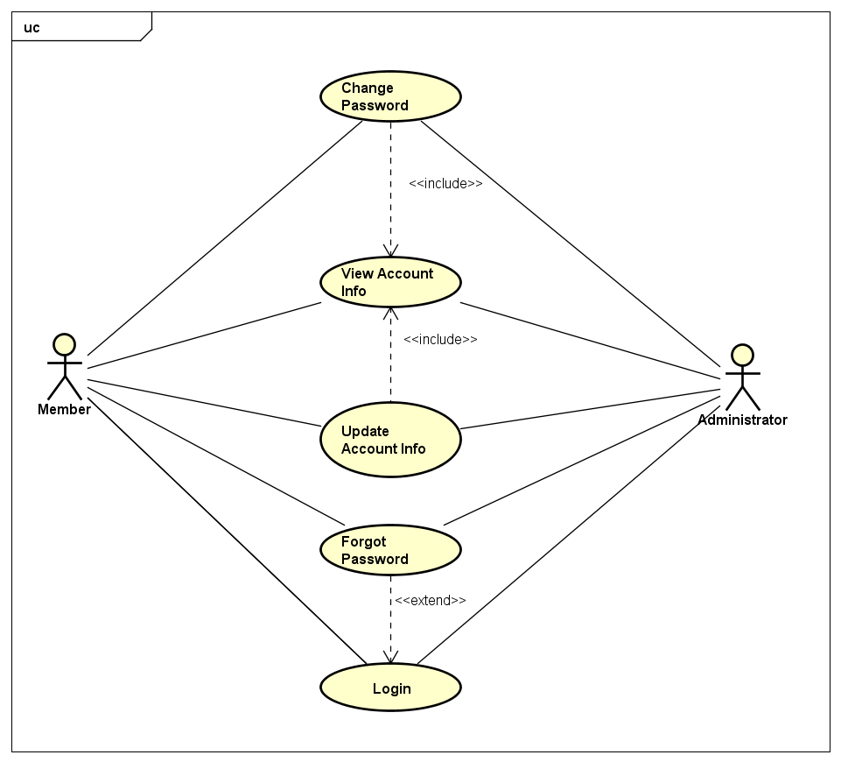

1. Account Group Use Cases for Registered User

#### UC012 – View Account Info

1. Detailed Use Case description and Registered User - System interactions

|  |  |  |  |  |
| --- | --- | --- | --- | --- |
| Use Case ID | | UC012 | Version | 1.0 |
| Use Case Name | | View Account Info | | |
| Author | | Trần Đăng | **Last Updated** | 26/05/2016 |
| Primary Actor | | RU | **Secondary Actor** |  |
| Description | | Display RU’s info | | |
| Preconditions | | Logged in  Currently at Detailed Review|Manage Accounts (AD) screen | | |
| Postconditions | | Detailed Account Info screen is displayed | | |
| Normal Flow | | | | |
| Step | **Actor** | **Action** | | |
| 1 | RU | Click on a RU’s name | | |
| 2 | System | Return RU’s info and available actions depending on RU’s access level | | |
|  | | | | |
| Alternative Flows | | | | |
| AT1 | User access the RU’s Detailed Account Info through an existing URL | | | |
| Step | **Actor** | **Actor** | | |
| 1 | User | Open the URL for the RU’s Detailed Account Info | | |
| 2 | System | Return RU’s info and available actions depending on RU’s access level | | |
|  | | | | |
| Exceptions: None | | | | |
| Priority | | High | | |
| Frequency of Use | | Normal | | |
| Business Rules | | B6 | | |

#### UC013 – Update Account Info

1. Detailed Use Case description and Registered User - System interactions

|  |  |  |  |  |
| --- | --- | --- | --- | --- |
| Use Case ID | | UC013 | Version | 1.0 |
| Use Case Name | | Update Account Info | | |
| Author | | Trần Đăng | **Last Updated** | 26/05/2016 |
| Primary Actor | | RU | **Secondary Actor** |  |
| Description | | Change RU’s account info | | |
| Preconditions | | Logged in  Currently at RU’s own Detailed Account Info screen | | |
| Postconditions | | RU’s account is successfully updated in the system | | |
| Normal Flow | | | | |
| Step | **Actor** | **Action** | | |
| 1 | RU | Make changes as needed and click on “Cập nhật” | | |
| 2 | System | Save changes into the system | | |
|  | | | | |
| Alternative Flows | | | | |
|  | | | | |
| Exceptions: None | | | | |
| EX1 | At step 1 changes did not fulfill system’s requirement | | | |
| Step | **Actor** | **Action** | | |
| 2 | System | Display error messages accordingly and halt RU progress until cleared | | |
| Priority | | High | | |
| Frequency of Use | | Normal | | |
| Business Rules | | None | | |

#### UC014 – Change Password

1. Detailed Use Case description and Registered User - System interactions

|  |  |  |  |  |
| --- | --- | --- | --- | --- |
| Use Case ID | | UC014 | Version | 1.0 |
| Use Case Name | | Change Password | | |
| Author | | Trần Đăng | **Last Updated** | 26/05/2016 |
| Primary Actor | | RU | **Secondary Actor** |  |
| Description | | Change the account password | | |
| Preconditions | | Logged in  Currently at RU’s own Detailed Account Info screen | | |
| Postconditions | | RU’s account password is successfully updated in the system | | |
| Normal Flow | | | | |
| Step | **Actor** | **Action** | | |
| 1 | RU | Make changes as needed and click on “Lưu mật khẩu” | | |
| 2 | System | Save changes into the system | | |
|  | | | | |
| Alternative Flows: None | | | | |
|  | | | | |
| Exceptions | | | | |
| EX1 | At step 1 changes did not fulfill system’s requirement | | | |
| Step | **Actor** | **Action** | | |
| 2 | System | Display error messages accordingly and halt RU progress until cleared | | |
|  | | | | |
| Priority | | High | | |
| Frequency of Use | | Low | | |
| Business Rules | | B12 | | |

#### UC015 – Forgot Password

1. Detailed Use Case description and Registered User - System interactions

|  |  |  |  |  |
| --- | --- | --- | --- | --- |
| Use Case ID | | UC015 | Version | 1.0 |
| Use Case Name | | Lấy lại mật khẩu | | |
| Author | | Trần Đăng | **Last Updated** | 26/05/2016 |
| Primary Actor | | RU | **Secondary Actor** |  |
| Description | | RU forgot password and want to access an owned account | | |
| Preconditions | | Currently at Login screen | | |
| Postconditions | | RU can login to the account and change password as needed | | |
| Normal Flow | | | | |
| Step | **Actor** | **Action** | | |
| 1 | RU | Click on “Quên mật khẩu” | | |
| 2 | System | Display Forgot Password screen | | |
| 3 | RU | Input account’s registered email and click “Submit” | | |
| 4 | System | Show message “Đã gửi mail” and send a reset password email accordingly | | |
| 5 | RU | Click on the mail’s URL | | |
| 6 | System | Display Change Password screen, refer to UC014 | | |
|  | | | | |
| Alternative Flows | | | | |
| AT1 | After step 3, RU does not have a password due to logging in by Facebook | | | |
| Step | **Actor** | **Action** | | |
| 4 | System | Show message “Top of Form  Có vẻ bạn đã đăng ký bằng tài khoản FacebookBottom of Form  ”. End of Use Case | | |
|  | | | | |
| Exceptions | | | | |
| EX1 | After step 3, email does not belong to any account | | | |
| Step | **Actor** | **Action** | | |
| 4 | System | Show message “Không tìm thấy tài khoản tương ứng” | | |
|  | | | | |
| Priority | | High | | |
| Frequency of Use | | Low | | |
| Business Rules | | None | | |

Comment

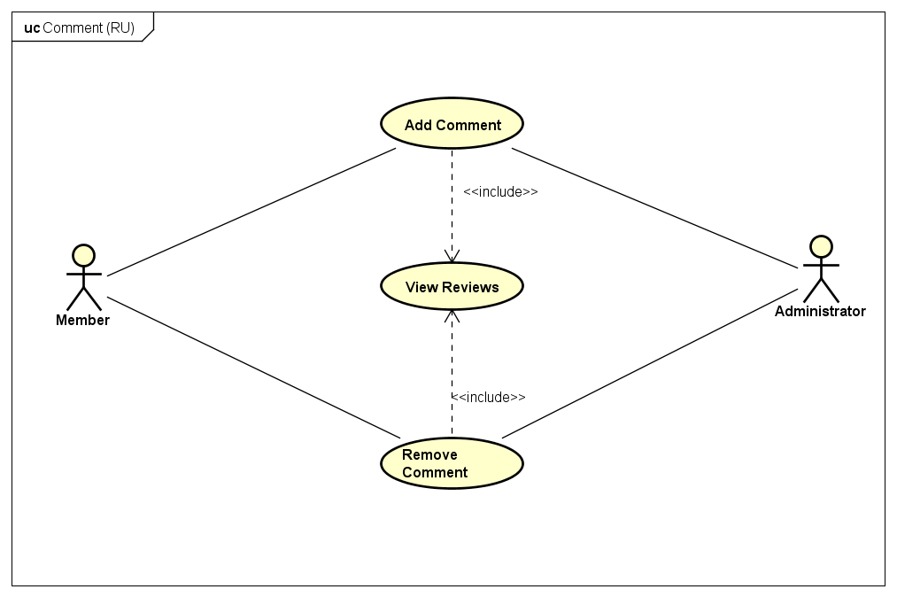

1. Comment Group Use Cases for Registered User

#### UC016 – Add Comment

1. Detailed Use Case description and Registered User - System interactions

|  |  |  |  |  |
| --- | --- | --- | --- | --- |
| Use Case ID | | UC016 | Version | 1.0 |
| Use Case Name | | Add Comment | | |
| Author | | Trần Đăng | **Last Updated** | 26/05/2016 |
| Primary Actor | | RU | **Secondary Actor** |  |
| Description | | Post a comment on a review | | |
| Preconditions | | Logged in  Currently at Detailed Review screen | | |
| Postconditions | | Comment is successfully saved into the system | | |
| Normal Flow | | | | |
| Step | **Actor** | **Action** | | |
| 1 | RU | Input comment and click “Gửi bình luận” | | |
| 2 | System | Save the comment into the system and show it on the comment section | | |
|  | | | | |
| Alternative Flows: None | | | | |
|  | | | | |
| Exceptions: None | | | | |
| Priority | | Low | | |
| Frequency of Use | | High | | |
| Business Rules | | None | | |

#### UC017 – Remove Comment

1. Detailed Use Case description and Registered User - System interactions

|  |  |  |  |  |
| --- | --- | --- | --- | --- |
| Use Case ID | | UC017 | Version | 1.0 |
| Use Case Name | | Remove Comment | | |
| Author | | Trần Đăng | **Last Updated** | 26/05/2016 |
| Primary Actor | | RU | **Secondary Actor** |  |
| Description | | Remove an owned comment on a review | | |
| Preconditions | | Logged in  Currently at Detailed Review screen | | |
| Postconditions | | Comment is successfully removed from the system | | |
| Normal Flow | | | | |
| Step | **Actor** | **Action** | | |
| 1 | RU | Click on “Xóa” from the dropdown menu on the owned comment | | |
| 2 | System | Remove comment from the system | | |
|  | | | | |
| Alternative Flows: None | | | | |
|  | | | | |
| Exceptions: None | | | | |
| Priority | | Low | | |
| Frequency of Use | | High | | |
| Business Rules | | None | | |

Company

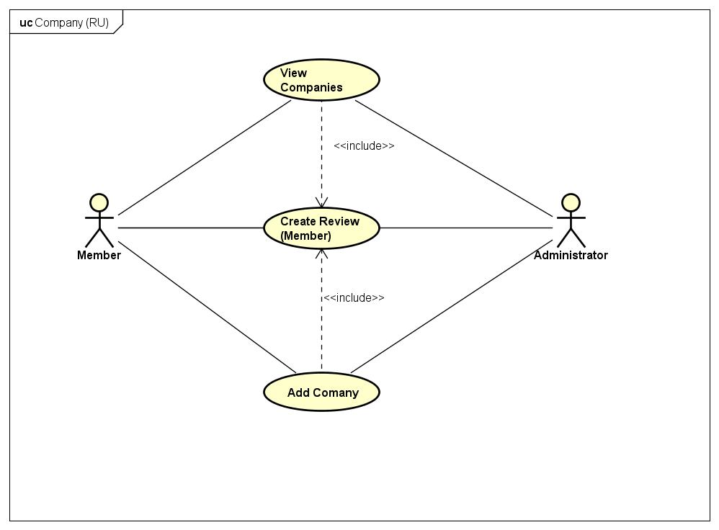

1. Company Group Use Cases for Registered User

#### UC018 – Add Company

1. Detailed Use Case description and Registered User - System interactions

|  |  |  |  |  |
| --- | --- | --- | --- | --- |
| Use Case ID | | UC018 | Version | 1.0 |
| Use Case Name | | Add Company | | |
| Author | | Trần Đăng | **Last Updated** | 27/05/2016 |
| Primary Actor | | RU | **Secondary Actor** |  |
| Description | | Add a new company to the system | | |
| Preconditions | | New company is not currently exist in the system  Currently at Manage Companies screen (AD)  Currently at View Companies List screen(Member) | | |
| Postconditions | | New company is successfully saved into the system | | |
| Normal Flow | | | | |
| Step | **Actor** | **Action** | | |
| 1 | RU | Click on “Tạo công ty mới” | | |
| 2 | System | Display Add Company screen | | |
| 3 | RU | Input info as required and click “Tạo công ty” | | |
| 4 | System | Save new company info into the system | | |
|  | | | | |
| Alternative Flows: None | | | | |
|  | | | | |
| Exceptions | | | | |
| EX1 | At step 3, RU did not input all required info | | | |
| Step | **Actor** | **Action** | | |
| 4 | System | Display error messages accordingly and halt RU progress until cleared | | |
|  | | | | |
| Priority | | High | | |
| Frequency of Use | | Normal | | |
| Business Rules | | None | | |

### Member

Company

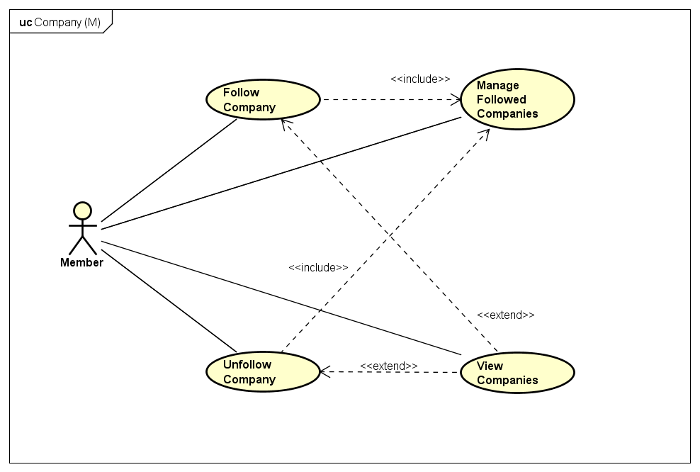

1. Company Group Use Cases for Member

#### UC019 – Manage Followed Companies

1. Detailed Use Case description and Member - System interactions

|  |  |  |  |  |
| --- | --- | --- | --- | --- |
| Use Case ID | | UC019 | Version | 1.0 |
| Use Case Name | | Manage Followed Companies | | |
| Author | | Trần Đăng | **Last Updated** | 27/05/2016 |
| Primary Actor | | Member | **Secondary Actor** |  |
| Description | | List all of member’s followed companies | | |
| Preconditions | | Logged in  Currently at Member’s own Detailed Account Info screen | | |
| Postconditions | | List of followed companies is successfully displayed | | |
| Normal Flow | | | | |
| Step | **Actor** | **Action** | | |
| 1 | Member | Click on “Công ty đang theo dõi” | | |
| 2 | System | Display list of followed companies | | |
|  | | | | |
| Alternative Flows | | | | |
| AT1 | After step 2, Member wants to limit the amount of shown companies on a single page | | | |
| Step | **Actor** | **Action** | | |
| 3 | Member | Click on the dropdown list next to “Hiển thị” and choose 5, 10 or 20 | | |
| 4 | System | Limit the amount of companies accordingly | | |
|  | | | | |
| Exceptions | | | | |
| EX1 | At step 2, Member has yet to follow any company | | | |
| Step | **Actor** | **Action** | | |
| 2 | System | Show message “Chưa có công ty nào được theo dõi” | | |
|  | | | | |
| Priority | | Normal | | |
| Frequency of Use | | Low | | |
| Business Rules | | None | | |

#### UC020 – Follow Company

1. Detailed Use Case description and Member - System interactions

|  |  |  |  |  |  |
| --- | --- | --- | --- | --- | --- |
| Use Case ID | | | UC020 | Version | 1.0 |
| Use Case Name | | | Follow Company | | |
| Author | | | Trần Đăng | **Last Updated** | 27/05/2016 |
| Primary Actor | | | Member | **Secondary Actor** |  |
| Description | | | Allow member to receive notification from the chosen company | | |
| Preconditions | | | Logged in  Currently at Detailed Company screen | | |
| Postconditions | | | Company added to followed company list | | |
| Normal Flow | | | | | |
| Step | **Actor** | | **Action** | | |
| 1 | Member | | Click on “Theo dõi” | | |
| 2 | System | | Display a popup modal box asking for a confirmation | | |
| 3 | Member | | Click on “Xác nhận” | | |
| 4 | System | | Change the button to “Bỏ theo dõi” and save the chosen company to member’s followed company list | | |
|  | | | | | |
| Alternative Flows: None | | | | | |
|  | | | | | |
| Exceptions | | | | | |
| EX1 | At step 3 Member no longer want to remove review | | | | |
| Step | **Actor** | **Action** | | | |
| 3 | Member | Click on “Từ chối” | | | |
| 4 | System | Close the popup modal box | | | |
| Priority | | | Normal | | |
| Frequency of Use | | | Low | | |
| Business Rules | | | None | | |

#### UC021 – Unfollow Company

1. Detailed Use Case description and Member - System interactions

|  |  |  |  |  |  |
| --- | --- | --- | --- | --- | --- |
| Use Case ID | | | UC021 | Version | 1.0 |
| Use Case Name | | | Unfollow Company | | |
| Author | | | Trần Đăng | **Last Updated** | 27/05/2016 |
| Primary Actor | | | Member | **Secondary Actor** |  |
| Description | | | Allow member to no longer receive notification from the chosen company | | |
| Preconditions | | | Logged in  Currently following the chosen company  Currently at Detailed Company|Manage Followed Companies screen | | |
| Postconditions | | | Company removed from followed company list | | |
| Normal Flow | | | | | |
| Step | **Actor** | | **Action** | | |
| 1 | Member | | Click on “Bỏ theo dõi” | | |
| 2 | System | | Display a popup modal box asking for a confirmation | | |
| 3 | Member | | Click on “Xác nhận” | | |
| 4 | System | | Change the button to “Theo dõi” and remove the chosen company from member’s followed company list | | |
|  | | | | | |
| Alternative Flows: None | | | | | |
|  | | | | | |
| Exceptions | | | | | |
| EX1 | At step 3 Member no longer want to remove review | | | | |
| Step | **Actor** | **Action** | | | |
| 3 | Member | Click on “Từ chối” | | | |
| 4 | System | Close the popup modal box | | | |
| Priority | | | Normal | | |
| Frequency of Use | | | Low | | |
| Business Rules | | | None | | |

Review

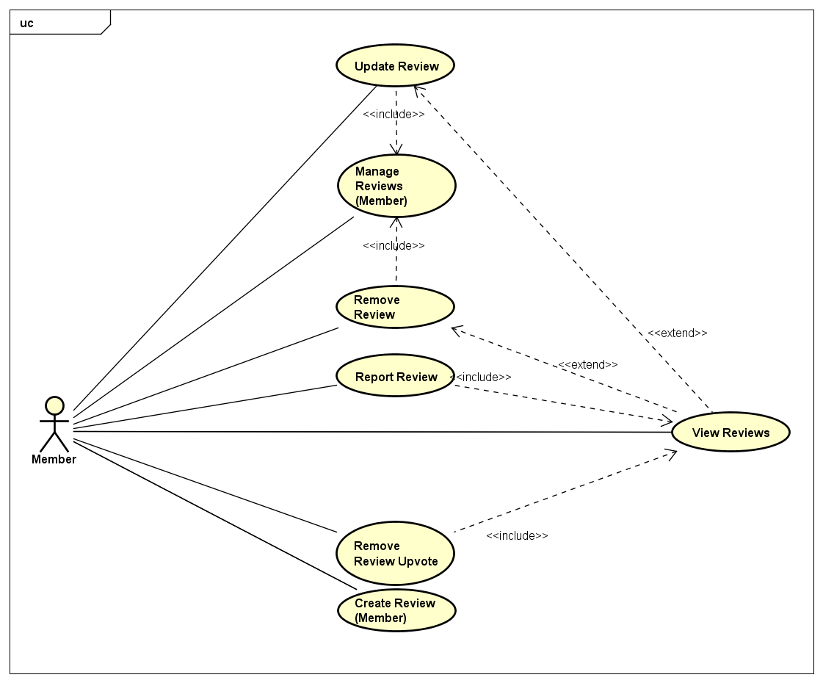

1. Group Use Cases for đánh giá của Member

#### UC022 – Manage Reviews

1. Detailed Use Case description and Member - System interactions

|  |  |  |  |  |
| --- | --- | --- | --- | --- |
| Use Case ID | | UC022 | Version | 1.0 |
| Use Case Name | | Manage Reviews | | |
| Author | | Trần Đăng | **Last Updated** | 27/05/2016 |
| Primary Actor | | Member | **Secondary Actor** |  |
| Description | | List all of member’s reviews | | |
| Preconditions | | Logged in  Currently at Member’s own Detailed Account Info screen | | |
| Postconditions | | List of member’s reviews is successfully displayed | | |
| Normal Flow | | | | |
| Step | **Actor** | **Action** | | |
| 1 | Member | Click on “Bài đánh giá đã đăng” | | |
| 2 | System | Display list of member’s reviews | | |
|  | | | | |
| Alternative Flows | | | | |
| A1 | After step 2, Member wants to limit the amount of shown reviews on a single page | | | |
| Step | **Actor** | **Action** | | |
| 3 | Member | Click on the dropdown list next to “Hiển thị” and choose 5, 10 or 20 | | |
| 4 | System | Limit the amount of companies accordingly | | |
|  | | | | |
| Exceptions | | | | |
| EX1 | At step 2, Member has no review | | | |
| Step | **Actor** | **Action** | | |
| 2 | System | Show message “Bạn chưa có đánh giá nào” | | |
|  | | | | |
| Priority | | High | | |
| Frequency of Use | | Normal | | |
| Business Rules | | None | | |

#### UC023 – Create Review

1. Detailed Use Case description and Member - System interactions

|  |  |  |  |  |
| --- | --- | --- | --- | --- |
| Use Case ID | | UC023 | Version | 1.0 |
| Use Case Name | | Create Review | | |
| Author | | Trần Đăng | **Last Updated** | 27/05/2016 |
| Primary Actor | | Member | **Secondary Actor** |  |
| Description | | Post a review to CRW with an account | | |
| Preconditions | | Logged in | | |
| Postconditions | | Review is saved in the system | | |
| Normal Flow | | | | |
| Step | **Actor** | **Action** | | |
| 1 | Member | Click on “+ Đánh giá” | | |
| 2 | System | Display Create Review screen | | |
| 3 | Member | Input info as required and click “Gửi đánh giá” | | |
| 4 | System | Save the review into the system with pending state | | |
|  | | | | |
| Alternative Flows: None | | | | |
|  | | | | |
| Exceptions | | | | |
| EX1 | At step 3 Member did not input all required info | | | |
| Step | **Actor** | **Action** | | |
| 4 | System | Display error messages accordingly and halt member progress until cleared | | |
| Priority | | High | | |
| Frequency of Use | | High | | |
| Business Rules | | None | | |

#### UC024 – Update Review

1. Detailed Use Case description and Member - System interactions

|  |  |  |  |  |
| --- | --- | --- | --- | --- |
| Use Case ID | | UC024 | Version | 1.0 |
| Use Case Name | | Update Review | | |
| Author | | Trần Đăng | **Last Updated** | 27/05/2016 |
| Primary Actor | | Member | **Secondary Actor** |  |
| Description | | Update a posted review | | |
| Preconditions | | Logged in  Is the owner of the review  Currently at Detailed Review|Manage Reviews screen | | |
| Postconditions | | Member’s changes are successfully saved in the system | | |
| Normal Flow | | | | |
| Step | **Actor** | **Action** | | |
| 1 | Member | Click on “Cập nhật đánh giá” | | |
| 2 | System | Display Update Review screen | | |
| 3 | Member | Make changes as needed and click on “Cập nhật” | | |
| 4 | System | Save changes into the system and change review’s state to pending | | |
|  | | | | |
| Alternative Flows: None | | | | |
|  | | | | |
| Exceptions | | | | |
| EX1 | At step 3 Member did not input all required info | | | |
| Step | **Actor** | **Action** | | |
| 4 | System | Display error messages accordingly and halt member progress until cleared | | |
| Priority | | High | | |
| Frequency of Use | | High | | |
| Business Rules | | None | | |

#### UC025 – Remove Review

1. Detailed Use Case description and Member - System interactions

|  |  |  |  |  |
| --- | --- | --- | --- | --- |
| Use Case ID | | UC025 | Version | 1.0 |
| Use Case Name | | Remove Review | | |
| Author | | Trần Đăng | **Last Updated** | 27/05/2016 |
| Primary Actor | | Member | **Secondary Actor** |  |
| Description | | Remove a posted and approved review | | |
| Preconditions | | Logged in  Is the owner of the review  Currently at Detailed Review|Manage Reviews screen | | |
| Postconditions | | Review is successfully removed from the system | | |
| Normal Flow | | | | |
| Step | **Actor** | **Action** | | |
| 1 | Member | Click on “Xóa bài đánh giá” | | |
| 2 | System | Display a popup modal box asking for a confirmation | | |
| 3 | Member | Click on “Xác nhận” | | |
| 4 | System | Remove the review from the system | | |
|  | | | | |
| Alternative Flows: None | | | | |
|  | | | | |
| Exceptions | | | | |
| EX1 | At step 3 Member no longer want to remove review | | | |
| Step | **Actor** | **Action** | | |
| 3 | Member | Click on “Từ chối” | | |
| 4 | System | Close the popup modal box | | |
| Priority | | High | | |
| Frequency of Use | | Normal | | |
| Business Rules | | None | | |

#### UC026 – Report Review

1. Detailed Use Case description and Member - System interactions

|  |  |  |  |  |
| --- | --- | --- | --- | --- |
| Use Case ID | | UC026 | Version | 1.0 |
| Use Case Name | | Report Review | | |
| Author | | Trần Đăng | **Last Updated** | 27/05/2016 |
| Primary Actor | | Member | **Secondary Actor** |  |
| Description | | Report a rule violating or false-flagging review on CRW | | |
| Preconditions | | Logged in  Currently at Detailed Review screen | | |
| Postconditions | | Report is successfully logged into the system | | |
| Normal Flow | | | | |
| Step | **Actor** | **Action** | | |
| 1 | Member | Click on “Báo cáo vi phạm” | | |
| 2 | System | Display reasoning and confirmation popup modal box | | |
| 3 | Member | Input reasoning and click on “Gửi báo cáo” | | |
| 4 | System | Log the report into the system | | |
|  | | | | |
| Alternative Flows: None | | | | |
|  | | | | |
| Exceptions | | | | |
| EX1 | At step 3 Member no longer want to report | | | |
| Step | **Actor** | **Action** | | |
| 3 | Member | Click on “Hủy báo cáo” | | |
| 4 | System | Close the popup modal box | | |
| Priority | | Normal | | |
| Frequency of Use | | Normal | | |
| Business Rules | | None | | |

#### UC027 – Upvote Review

1. Detailed Use Case description and Member - System interactions

|  |  |  |  |  |
| --- | --- | --- | --- | --- |
| Use Case ID | | UC027 | Version | 1.0 |
| Use Case Name | | Upvote Review | | |
| Author | | Trần Đăng | **Last Updated** | 27/05/2016 |
| Primary Actor | | Member | **Secondary Actor** |  |
| Description | | Upvote a review to the member’s liking | | |
| Preconditions | | Logged in  Currently at Detailed Review screen | | |
| Postconditions | | Increase the amount of upvote on the review by 1 | | |
| Normal Flow | | | | |
| Step | **Actor** | **Action** | | |
| 1 | Member | Click on “Ủng hộ” | | |
| 2 | System | Display a popup modal box asking for a confirmation | | |
| 3 | Member | Click on “Xác nhận” | | |
| 4 | System | Change the button to “Bỏ ủng hộ” and increase the mount of upvote by 1 | | |
|  | | | | |
| Alternative Flows: None | | | | |
|  | | | | |
| Exceptions | | | | |
| EX1 | At step 3 Member no longer want to upvote the review | | | |
| Step | **Actor** | **Action** | | |
| 3 | Member | Click on “Từ chối” | | |
| 4 | System | Close the popup modal box | | |
| Priority | | High | | |
| Frequency of Use | | High | | |
| Business Rules | | None | | |

#### UC028 – Remove Review Upvote

1. Detailed Use Case description and Member - System interactions

|  |  |  |  |  |
| --- | --- | --- | --- | --- |
| Use Case ID | | UC028 | Version | 1.0 |
| Use Case Name | | Remove Review Upvote | | |
| Author | | Trần Đăng | **Last Updated** | 27/05/2016 |
| Primary Actor | | Member | **Secondary Actor** |  |
| Description | | Remove member’s upvote from a review | | |
| Preconditions | | Logged in  Currently upvoted the chosen review  Currently at Detailed Review screen | | |
| Postconditions | | Decrease the amount of upvote on the review by 1 | | |
| Normal Flow | | | | |
| Step | **Actor** | **Action** | | |
| 1 | Member | Click on “Bỏ ủng hộ” | | |
| 2 | System | Display a popup modal box asking for a confirmation | | |
| 3 | Member | Click on “Xác nhận” | | |
| 2 | System | Change the button to “Ủng hộ” and decrease the amount of upvote by 1 | | |
|  | | | | |
| Alternative Flows: None | | | | |
|  | | | | |
| Exceptions | | | | |
| EX1 | At step 3 Member no longer want to remove upvote from the review | | | |
| Step | **Actor** | **Action** | | |
| 3 | Member | Click on “Từ chối” | | |
| 4 | System | Close the popup modal box | | |
| Priority | | High | | |
| Frequency of Use | | High | | |
| Business Rules | | None | | |

Bookmark

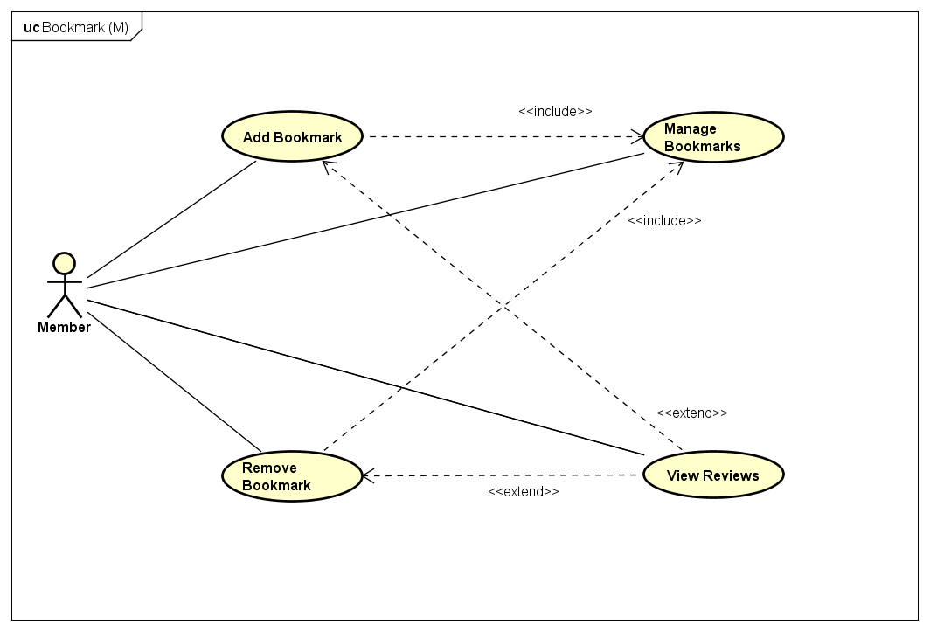

1. Bookmark Group Use Cases for Member

#### UC029 – Manage Bookmarks

1. Detailed Use Case description and Member - System interactions

|  |  |  |  |  |
| --- | --- | --- | --- | --- |
| Use Case ID | | UC029 | Version | 1.0 |
| Use Case Name | | Manage Bookmarks | | |
| Author | | Trần Đăng | **Last Updated** | 27/05/2016 |
| Primary Actor | | Member | **Secondary Actor** |  |
| Description | | Member có nhu cầu xem các review mình đã đánh dấu trang | | |
| Preconditions | | Logged in  Currently at Member’s own Detailed Account Info screen | | |
| Postconditions | | Hiển thị danh sách các review đã được đánh dấu trang của Member | | |
| Normal Flow | | | | |
| Step | **Actor** | **Action** | | |
| 1 | Member | Click on “Bài đánh giá đã đánh dấu” | | |
| 2 | System | Display list of member’s bookmarked reviews | | |
|  | | | | |
| Alternative Flows | | | | |
| A1 | After step 2, Member wants to limit the amount of shown reviews on a single page | | | |
| Step | **Actor** | **Action** | | |
| 3 | Member | Click on the dropdown list next to “Hiển thị” and choose 5, 10 or 20 | | |
| 4 | System | Limit the amount of companies accordingly | | |
|  | | | | |
| Exceptions | | | | |
| EX1 | At step 2, Member has yet to bookmark any review | | | |
| Step | **Actor** | **Action** | | |
| 2 | System | Show message “Chưa có bài đánh giá nào được lưu dấu trang” | | |
|  | | | | |
| Priority | | Normal | | |
| Frequency of Use | | Normal | | |
| Business Rules | | None | | |

#### UC030 – Add Bookmark

1. Detailed Use Case description and Member - System interactions

|  |  |  |  |  |
| --- | --- | --- | --- | --- |
| Use Case ID | | UC030 | Version | 1.0 |
| Use Case Name | | Add Bookmark | | |
| Author | | Trần Đăng | **Last Updated** | 27/05/2016 |
| Primary Actor | | Member | **Secondary Actor** |  |
| Description | | Create a bookmark to keep the reviews for later usages | | |
| Preconditions | | Logged in  Currently at Detailed Review screen | | |
| Postconditions | | New bookmark is successfully saved in the system | | |
| Normal Flow | | | | |
| Step | **Actor** | **Action** | | |
| 1 | Member | Click on “Dấu trang” | | |
| 2 | System | Change the button to “Bỏ lưu dấu trang” and save the bookmark to the member’s list | | |
|  | | | | |
| Alternative Flows: None | | | | |
|  | | | | |
| Exceptions: None | | | | |
| Priority | | Normal | | |
| Frequency of Use | | Normal | | |
| Business Rules | | None | | |

#### UC031 – Remove Bookmark

1. Detailed Use Case description and Member - System interactions

|  |  |  |  |  |
| --- | --- | --- | --- | --- |
| Use Case ID | | UC031 | Version | 1.0 |
| Use Case Name | | Remove Bookmark | | |
| Author | | Trần Đăng | **Last Updated** | 27/05/2016 |
| Primary Actor | | Member | **Secondary Actor** |  |
| Description | | Remove a bookmark from a review | | |
| Preconditions | | Logged in  Currently at Detailed Review|Manage Bookmark screen | | |
| Postconditions | | Bookmark is successffully removed from the member’s list | | |
| Normal Flow | | | | |
| Step | **Actor** | **Action** | | |
| 1 | Member | Click on “Bỏ lưu dấu trang” | | |
| 2 | System | Change the button to “Dấu trang” and remove the review from member’s bookmark list | | |
|  | | | | |
| Alternative Flows: None | | | | |
|  | | | | |
| Exceptions: None | | | | |
| Priority | | Normal | | |
| Frequency of Use | | Normal | | |
| Business Rules | | None | | |

### Administrator

Company

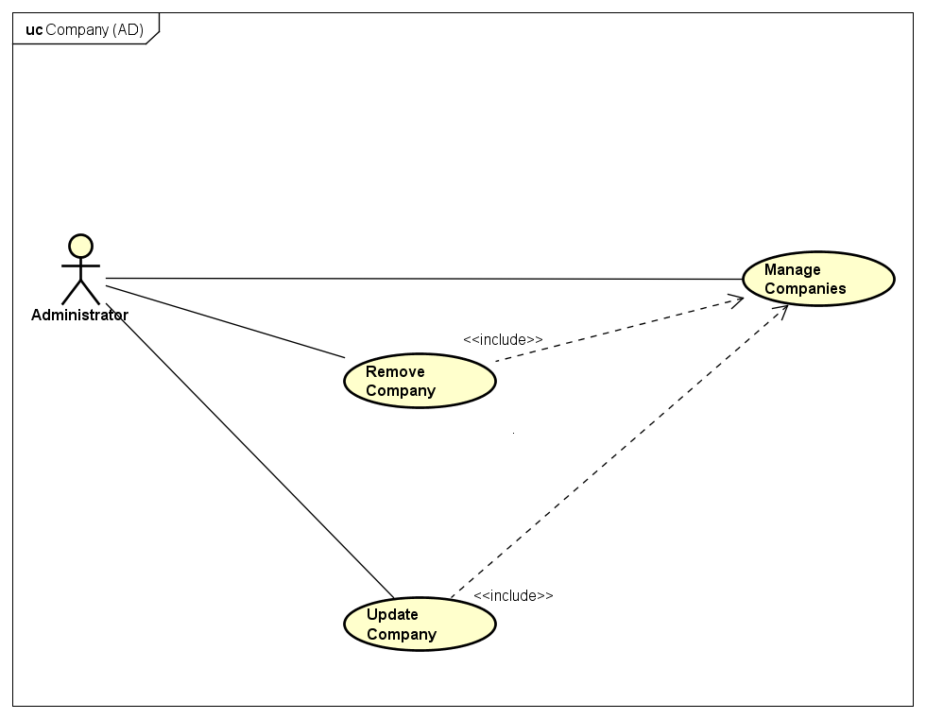

1. Company Group Use Cases for Administrator

#### UC032 – Manage Companies

1. Detailed Use Case description and Administrator - System interactions

|  |  |  |  |  |
| --- | --- | --- | --- | --- |
| Use Case ID | | UC032 | Version | 1.0 |
| Use Case Name | | Manage Companies | | |
| Author | | Trần Đăng | **Last Updated** | 27/05/2016 |
| Primary Actor | | AD | **Secondary Actor** |  |
| Description | | List all companies available in the system | | |
| Preconditions | | Logged in as an AD  Currently at AD Control Panel screen | | |
| Postconditions | | List of all available companies is successfully displayed | | |
| Normal Flow | | | | |
| Step | **Actor** | **Action** | | |
| 1 | AD | Click on “Quản lý thống kê” | | |
| 2 | System | Display dropdown menu | | |
| 3 | AD | Click on “Các công ty” | | |
| 4 | System | Display Manage Companies screen with all companies’ info | | |
|  | | | | |
| Alternative Flows | | | | |
| A1 | After step 2, AD wants to limit the amount of shown companies on a single page | | | |
| Step | **Actor** | **Action** | | |
| 3 | AD | Click on the dropdown list next to “Hiển thị” and choose 10, 20 or 30 | | |
| 4 | System | Limit the amount of companies accordingly | | |
|  | | | | |
| Exceptions | | | | |
| EX1 | At step 2, if there is no company in the system | | | |
| Step | **Actor** | **Action** | | |
| 2 | System | Show message “Hệ thống chưa có công ty nào” | | |
|  | | | | |
| Priority | | High | | |
| Frequency of Use | | Normal | | |
| Business Rules | | None | | |

#### UC033 – Update Company

1. Detailed Use Case description and Administrator - System interactions

|  |  |  |  |  |
| --- | --- | --- | --- | --- |
| Use Case ID | | UC033 | Version | 1.0 |
| Use Case Name | | Update Company | | |
| Author | | Trần Đăng | **Last Updated** | 27/05/2016 |
| Primary Actor | | AD | **Secondary Actor** |  |
| Description | | Update the info of an existing company within the system | | |
| Preconditions | | Logged in as an AD  Currently at Manage Companies screen | | |
| Postconditions | | Company’s info is successfully updated in the system | | |
| Normal Flow | | | | |
| Step | **Actor** | **Action** | | |
| 1 | AD | Click on “Sửa thông tin” | | |
| 2 | System | Display popup modal box for updating purpose | | |
| 3 | AD | Make changes as needed and click on “Lưu chỉnh sửa” | | |
| 4 | System | Save changes into the system | | |
|  | | | | |
| Alternative Flows: None | | | | |
|  | | | | |
| Exceptions | | | | |
| EX1 | At step 3, AD did not input all required info | | | |
| Step | **Actor** | **Action** | | |
| 4 | System | Display error messages accordingly and halt member progress until cleared | | |
| Priority | | High | | |
| Frequency of Use | | Normal | | |
| Business Rules | | None | | |

#### UC034 – Remove Company

1. Detailed Use Case description and Administrator - System interactions

|  |  |  |  |  |
| --- | --- | --- | --- | --- |
| Use Case ID | | UC034 | Version | 1.0 |
| Use Case Name | | Remove Company | | |
| Author | | Trần Đăng | **Last Updated** | 27/05/2016 |
| Primary Actor | | AD | **Secondary Actor** |  |
| Description | | Remove a company from the system | | |
| Preconditions | | Logged in as an AD  Currently at Update Company modal box | | |
| Postconditions | | Company’s state is successfully changed | | |
| Normal Flow | | | | |
| Step | **Actor** | **Action** | | |
| 1 | AD | Click on “Khóa” option in radiobox | | |
| 4 | System | Change company’s state to locked and save into the system | | |
|  | | | | |
| Alternative Flows: None | | | | |
|  | | | | |
| Exceptions | | | | |
| EX1 | After step 2, AD no longer want to remove the company | | | |
| Step | **Actor** | **Action** | | |
| 3 | AD | Click on “Từ chối” | | |
| 4 | System | Close the popup modal box | | |
| Priority | | High | | |
| Frequency of Use | | Normal | | |
| Business Rules | | None | | |

Reviews

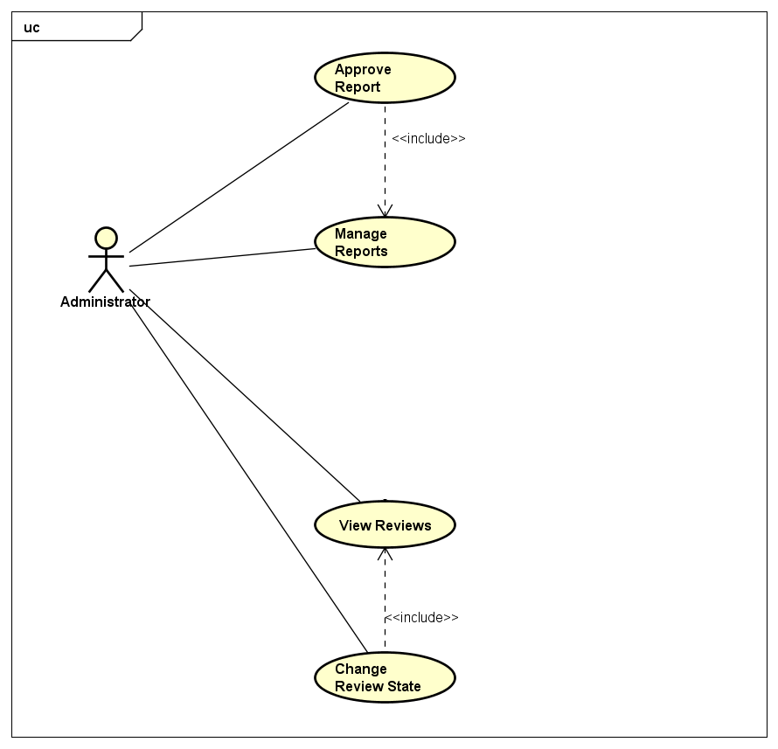

1. Review Group Use Cases for AD

#### UC035 – Manage Reports

1. Detailed Use Case description and Administrator - System interactions

|  |  |  |  |  |
| --- | --- | --- | --- | --- |
| Use Case ID | | UC035 | Version | 1.0 |
| Use Case Name | | Manage Reports | | |
| Author | | Trần Đăng | **Last Updated** | 27/05/2016 |
| Primary Actor | | AD | **Secondary Actor** |  |
| Description | | List all reports available in the system | | |
| Preconditions | | Logged in as an AD  Currently at AD Control Panel screen | | |
| Postconditions | | List of all available reports is successfully displayed | | |
| Normal Flow | | | | |
| Step | **Actor** | **Action** | | |
| 1 | AD | Click on “Xử lý bài đăng” | | |
| 2 | System | Display Manage Reviews screen | | |
| 3 | AD | Click on “Báo cáo chờ xử lý” tab | | |
| 4 | System | Display Manage Reports screen | | |
|  | | | | |
| Alternative Flows: None | | | | |
|  | | | | |
| Exceptions | | | | |
| EX1 | At step 2, if there is no existing report within the system | | | |
| Step | **Actor** | **Action** | | |
| 2 | System | Show message “Hiện thời chưa có báo cáo vi phạm nào” | | |
|  | | | | |
| Priority | | High | | |
| Frequency of Use | | High | | |
| Business Rules | | None | | |

#### UC036 – Approve Report

1. Detailed Use Case description and Administrator - System interactions

|  |  |  |  |  |
| --- | --- | --- | --- | --- |
| Use Case ID | | UC036 | Version | 1.0 |
| Use Case Name | | Approve Report | | |
| Author | | Trần Đăng | **Last Updated** | 27/05/2016 |
| Primary Actor | | AD | **Secondary Actor** |  |
| Description | | Available actions to take with a report | | |
| Preconditions | | Logged in as an AD  Currently at Manage Reports screen | | |
| Postconditions | | Report is successfully revised and has action taken against it | | |
| Normal Flow | | | | |
| Step | **Actor** | **Action** | | |
| 1 | AD | Click on the reports’ review title | | |
| 2 | System | Display Reported Review Details screen | | |
| 3 | AD | Click on “Xử lý” | | |
| 4 | System | Display popup modal box for reasoning and confirmation | | |
| 5 | AD | Input reasoning and click on “Xác nhận” | | |
| 6 | System | Review’s state is successfully changed to rejected and a notification is sent to the review’s owner | | |
|  | | | | |
| Alternative Flows: None | | | | |
|  | | | | |
| Exceptions | | | | |
| EX1 | At step 3, AD see that no action is needed | | | |
| Step | **Actor** | **Action** | | |
| 3 | AD | Click on “Bỏ qua” | | |
| 4 | System | Remove the report from the system | | |
|  | | | | |
| EX1 | At step 5, AD see that no action is needed yet | | | |
| Step | **Actor** | **Action** | | |
| 5 | AD | Click on “Hủy” | | |
| 6 | System | Close the popup modal box | | |
| Priority | | High | | |
| Frequency of Use | | High | | |
| Business Rules | | None | | |

Account

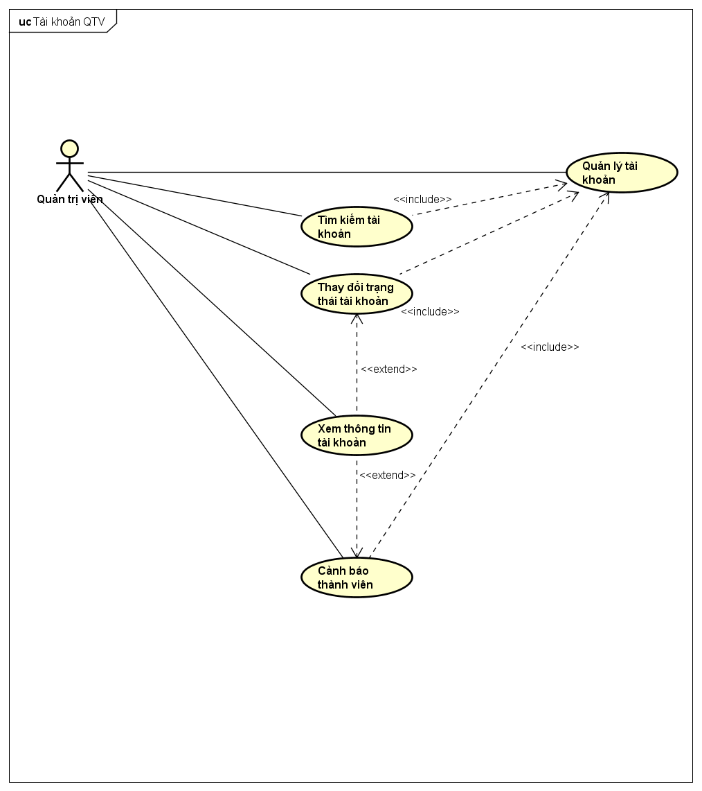

1. Group Use Cases for tài khoản của AD

#### UC037 – Manage Accounts

1. Detailed Use Case description and Administrator - System interactions

|  |  |  |  |  |
| --- | --- | --- | --- | --- |
| Use Case ID | | UC037 | Version | 1.0 |
| Use Case Name | | Manage Accounts | | |
| Author | | Trần Đăng | **Last Updated** | 27/05/2016 |
| Primary Actor | | AD | **Secondary Actor** |  |
| Description | | List all accounts in the system | | |
| Preconditions | | Logged in as an AD  Currently at AD Control Panel screen | | |
| Postconditions | | List of accounts is successfully displayed | | |
| Normal Flow | | | | |
| Step | **Actor** | **Action** | | |
| 1 | AD | Click on “Quản lý thống kê” | | |
| 2 | System | Display dropdown menu | | |
| 3 | AD | Click on “Người dùng” | | |
| 4 | System | Display Manage Accounts screen with all accounts’ info | | |
|  | | | | |
| Alternative Flows | | | | |
| AT1 | After step 2, AD wants to limit the amount of shown accounts on a single page | | | |
| Step | **Actor** | **Action** | | |
| 3 | AD | Click on the dropdown list next to “Hiển thị” and choose 10, 20 or 30 | | |
| 4 | System | Limit the amount of companies accordingly | | |
|  | | | | |
| Exceptions: None | | | | |
| Priority | | High | | |
| Frequency of Use | | High | | |
| Business Rules | | None | | |

#### UC038 – Search Account

1. Detailed Use Case description and Administrator - System interactions

|  |  |  |  |  |
| --- | --- | --- | --- | --- |
| Use Case ID | | UC038 | Version | 1.0 |
| Use Case Name | | Search Account | | |
| Author | | Trần Đăng | **Last Updated** | 27/05/2016 |
| Primary Actor | | AD | **Secondary Actor** |  |
| Description | | Search for accounts in the system, possibily with filter | | |
| Preconditions | | Logged in as an AD  Current at Manage Accounts screen | | |
| Postconditions | | Matching accounts are displayed | | |
| Normal Flow | | | | |
| Step | **Actor** | **Action** | | |
| 1 | AD | Input search query | | |
| 2 | System | Display Manage Accounts screen with matching result | | |
|  | | | | |
| Alternative Flows | | | | |
| AT1 | After step 2, AD wants to limit the amount of search result on a single page | | | |
| Step | **Actor** | **Action** | | |
| 3 | AD | Click on the dropdown list next to “Hiển thị” and choose 10, 20 or 30 | | |
| 4 | System | Limit the search result accordingly | | |
|  | | | | |
| Exceptions: None | | | | |
| Priority | | High | | |
| Frequency of Use | | High | | |
| Business Rules | | None | | |

#### UC039 – Change Account State

1. Detailed Use Case description and Administrator - System interactions

|  |  |  |  |  |
| --- | --- | --- | --- | --- |
| Use Case ID | | UC039 | Version | 1.0 |
| Use Case Name | | Change Account State | | |
| Author | | Trần Đăng | **Last Updated** | 27/05/2016 |
| Primary Actor | | AD | **Secondary Actor** |  |
| Description | | Change an account state accordingly to the rules | | |
| Preconditions | | Logged in as an AD  Currently at Detailed Account Info screen | | |
| Postconditions | | Account’s state is successfully changed | | |
| Normal Flow | | | | |
| Step | **Actor** | **Action** | | |
| 1 | AD | Click on “Khóa” | | |
| 2 | System | Change the button to “Mở khóa” and save the account state into the system | | |
|  | | | | |
| Alternative Flows | | | | |
| AT1 | At step 1, if account is already banned | | | |
| Step | **Actor** | **Action** | | |
| 5 | AD | Click on “Mở khóa” | | |
| 6 | System | Change the button to “Khóa” and save the account state into the system | | |
|  | | | | |
| Exceptions: None | | | | |
| Priority | | Low | | |
| Frequency of Use | | Low | | |
| Business Rules | | None | | |

# NON-FUNCTIONAL SPECIFICATION

## Reliability

* Mean time between each failure is expected to be around 480 hours of actual usage.
* Maximum bugs per function are 2 bugs/function within 2 months of actual usage.
* Average number of bugs in the software during system testing is expected to be around 1 bug/KLOC.
* Database must be backed up on a daily basis and can be recovered whenever necessary.

## Performance Requirements

### Availability

Website must be available 95% of the time. Users can access to it from their Web browser with an Internet connection wherever they want.

### Response time

In term of response time, waiting time of processing will be 2 to 5 seconds; time to process any function will not exceed 7 seconds.

### Maintainability

* **Coding standards and naming conventions:**
* Output of the project must include coding standards and naming conventions documentations. Implementation code must be easy to maintain.
* If some components are reused, the documentations of those components must also be included.
* **Design:**
* The design of the system must be loosely coupled so that changes on one module will not affect another.
* **Logging:**
* All the errors should be logged to support bug fixing and maintenance.
* All strange or sensitive situations should also be logged.
* **Repair mean time:**
* Immediately when Administrator found a problem or website is attacked/hacked. Average 1 day.

## Hardware/Software Requirements

* **Hardware:** capable of using the required softwares
* **Software:**
* Server: Windows 7 or later, MongoDB, Express.JS, Angular.JS, Node.JS
* Client: Google Chrome, Firefox with Internet connection

## Information Requirements

* **Review States:** Pending, Approved, Rejected, Hightlighted
* **Account States:** Active, Banned
* **Registered Users:** Member, Moderator, Administrator